**CSS EXPERIMENT 4**

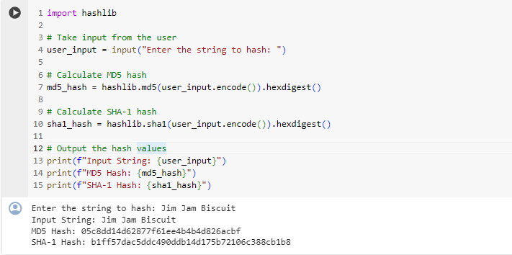

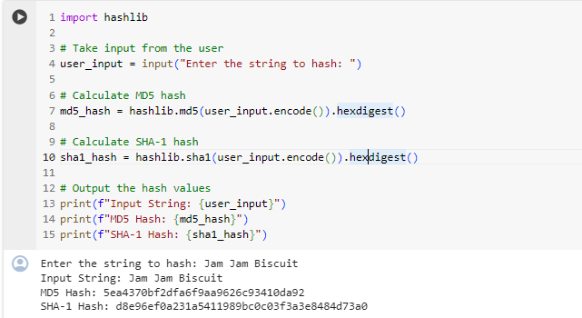

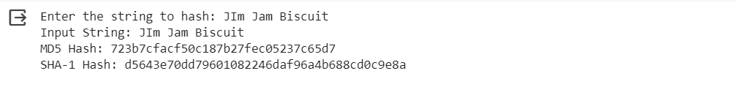

**Conclusion:**

1. The MD5 algorithm generates a 128-bit hash value, while SHA-1 produces a 160-bit hash value.
2. Even a small change in the input data, such as a single character, resulted in significantly different hash values for both MD5 and SHA-1.
3. Hash functions are highly sensitive to input changes.
4. The alteration of just one byte in the input led to entirely different hash outputs.
5. The experiment highlights the security strength of these hash functions in terms of sensitivity to input changes